Samantha White

Section 001

Grade ____________/ 36

**LAB 1 is divided into three parts, A, B, C.**

**Lab 1A** is an Internet search project and introduces the student to the Java API

**Lab 1B** is a Java program creation and shows the student how to submit projects for grading

**Lab 1C** is to install the Java development environment and JGRASP onto your home computer

# **LAB 1A – Internet project** – Familiarize yourself with the Java API

Assigned : 1/27

Due: 2/4

GOAL:

* Familiarize student with Java API website;
* Introduce useful methods to be used in Java programs.
* Show the structure of method headers

Go to:

[**https://docs.oracle.com/en/java/javase/15/docs/api/index.html**](https://docs.oracle.com/en/java/javase/15/docs/api/index.html)

The JavaTM Platform, Standard Edition & Java Development Kit Version 15 API Specification is one of the most useful parts of this website. An understanding of the API (Applications Programming Interface) is imperative to the design of Java programs. The APIs provide pieces of code that the programmer can incorporate into their programs and can use the code as if it were their own.

There are several parts to the documentation. We are interested in Java SE. Currently the orange tab shows “All Modules” Click on the Java SE next to the orange tab. Below are Modules and a Description. Click on the **java. base** Module. Scroll down until you see the word **Packages.**

The API is divided into packages. Packages contain classes. Classes contain methods. Methods contain java code. See page 5. We will use some of these methods in our Java programs.

Under Packages are two columns. The left column contains the name of the package. The right column contains the description of the package. Scroll down until you find the **java.io** package. What does it provide? (2 points)

Provides for system input and output through data streams, serialization and the file system.

The java.lang package is automatically provided for all Java programs. Find the **java.lang** package. What does it provide? (2 points)

Provides classes that are fundamental to the design of the Java programming language.

Clicking on any package will get a detailed description of the package. Click on **java.lang**. Scroll down to find the summaries (Shown in orange). There are 6 summaries of items contained in the java.lang package starting with the **Interface Summary**. List the six type of summaries which are written on orange tabs: (6 points)

**Interface** Summary **_____exception_______** Summary

**__class___** Summary **____error___________**  Summary

**__Enum__** Summary **____annotation_______**Summary

For now, we are interested in the Class Summary. This summary lists the classes that are contained in the package. The left column contains the name of the class. Notice that all class names start with a capital letter. The right column contains the description of the class. Scroll down until you find the **Math** class. What does it contain? (2 points)

The class Math contains methods for performing basic numeric operations such as the elementary exponential, logarithm, square root, and trigonometric functions.

Click on the word **Math**. You will get a detailed description of what is contained in the **Math** class. Notice the package name java.lang appears above the Class Math. Scroll below the description. The Math class description has two summaries just above the orange tabs. What are they? (2 points)

**_field____** Summary **_____method_**  Summary

**READ VERY CAREFULLY TO BE ABLE TO ANSWER REST OF THE QUESTIONS**

Scroll down to the Method Summary. The left column contains information about how the method is used and the return type of the method. The middle column contains the method name (bolded), the parameters (in parentheses). A brief description of the method is in the line to the right.

Examine the first line. The left column contains **static double**. For now, we will ignore the word **static.** The word **double** tells us that the return type of the method is **double**(a decimal number)**.** Almost all methods have a return type.

The first line of the middle column contains **abs(double a)**. This tells us that the name of the method is **abs**. **The name of the method is located immediately before the open parenthesis**. All methods require parenthesis. There may or may not be anything inside the parenthesis Parameter specification is contained inside the parenthesis.

This example has **double a** inside the parenthesis. This means that this method requires **one** parameter of type **double**. For now, we will ignore the letter **a**. Each parameter is specified by two words, the first word is a type (in this case **double**) and the second word is an identifier (in this case **a**). The right column is a description of the method.

Click on the name of the method, **abs**. You will get additional information about the method. Notice the line:

**public static double abs(double a)**

**This line is known as the method header (***sometimes it is called the method definition)*. This is what we saw in two columns with the added word **public.** For now we will ignore the word **public**. The return type, **double**, is the word located immediately before the name of the method.

At the top of the window click on **INDEX**

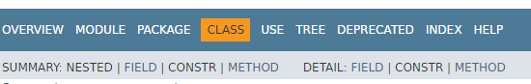

This will give you a list of all the classes that are provided in the JavaSE 15 API Specification.

You will see an alphabet and click on “S” to get all the classes starting with the letter “S”

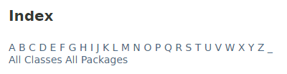

Find and click on the class: **StreamTokenizer – Class in java.io**

What package is the Stream Tokenizer class in? (2 points) **___java.io_______________________**

Scroll down the method summary until you find the method **nextToken** in the method summary. Click on the name of the method to get a detailed description of the method.

What is the method header? (2 points)_public int NextToken ( )

What is the return type? (2 points) _______________int____________________

How many parameters are required? (2 points) ­­­­__________none__**_**___________________

What does the method do? Write the first sentence only. (2 points)

Parses the next token from the input stream of this tokenizer.

Go back to the index and find and click on the class: **PrintStream – class in Java.io.**

Scroll down through the All Methods’ methods until you see the println methods.

How many println methods are in the class **PrintStream**? (2 points) _10

How many parameters are required for the method **println(String x)**? (2 points)___1

Click on the **println(String x)** method.

What is the entire method header? (2 points)___**___** public void println​([String](https://docs.oracle.com/en/java/javase/15/docs/api/java.base/java/lang/String.html) x)

What is the name of the method? (2 points) ____**______**__println_______________________

How many parameters are required? (2 points)______**_1_**_____________________________

What is the return type? (2 points) _________**void**_______________________________

Close the browser.

What have we learned?

* The Java API is divided into packages
* Packages contain classes
* Class names start with a capital letter
* Classes contain methods – The Java API shows us the method definitions
* The name of the method is directly to the left of the open parenthesis
* All methods require parenthesis
* Parameters are specified with a type followed by an identifier
* All methods have a return type (sometimes it is labeled void)
* The return type of the method is located directly to the left of the method name
* You can always find classes by going to the website

[**https://docs.oracle.com/en/java/javase/15/docs/api/index.html**](https://docs.oracle.com/en/java/javase/15/docs/api/index.html)

For the most up to date version of the API, no matter what version, see the next page.

<https://docs.oracle.com/en/>

A “Documentation” screen comes up, Choose Java

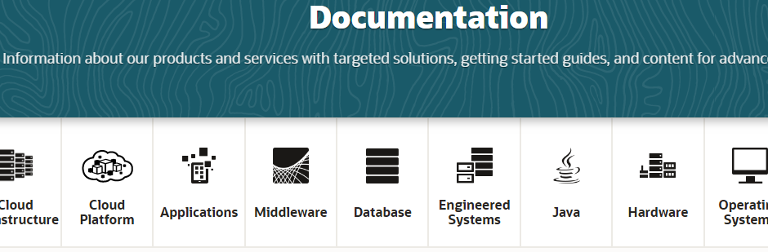

On the next screen choose, [Java SE documentation](http://docs.oracle.com/javase) a screen will open

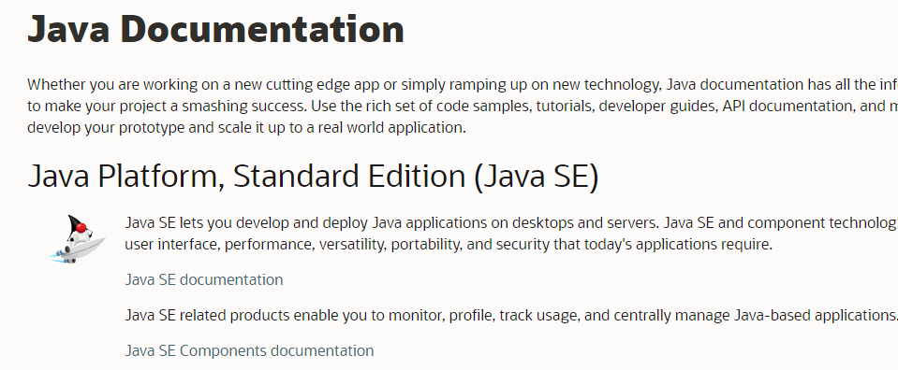

Another screen opens: On the left, choose API and click on it.

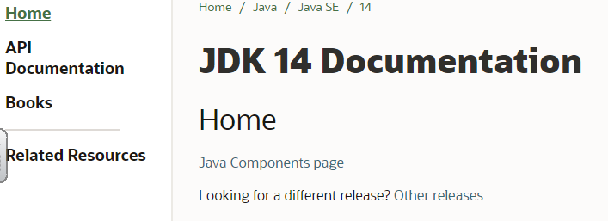

You will always get the latest version of the Java API this way

Method 2

Method 1